

IILM UNIVERSITY, GURUGRAM
SCHOOL OF COMPUTER SCIENCE & ENGINEERING

ASSIGNMENT
VERSION CONTROL SYSTEM

Submitted By: Suyash Rawat | Submitted to : Dr. Puja Batra
Section – 3A | (Associate Professor)
URN : 2581002

Problem Statement: Check Git Configuration.

Task : Configure your Git username and email and verify the configuration.

Commands used and screenshots:

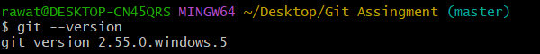
rawat@DESKTOP-CN45QRS MINGW64 ~/Desktop/Git Assingment (master)
$ git --version
git version 2.55.0.windows.5

rawat@DESKTOP-CN45QRS MINGW64 ~/Desktop/Git Assingment (master)
$ git config --global user.name "Suyash Rawat"

rawat@DESKTOP-CN45QRS MINGW64 ~/Desktop/Git Assingment (master)
$ git config --global user.email "suyash2006rawat@gmail.com"

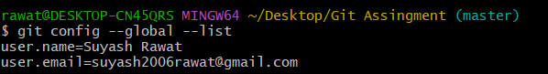

rawat@DESKTOP-CN45QRS MINGW64 ~/Desktop/Git Assingment (master)
$ git config --global --list
user.name=Suyash Rawat
user.email=suyash2006rawat@gmail.com

Learning Outcomes:
Configure Git username and email using Git commands.
Set global Git configuration for identifying the user.
Verify Git configuration using the git config command.
Understand the importance of user identity in Git commits.
Use basic Git configuration commands confidently.
GitHub Repository link: https://github.com/SuyashRawat2/Git-Assignment.git

